

Submitted by:
Name: Istiak Alam
ID: 05
Batch: 20
Lab report: 09
Date: 30.11.22
Course: CSE LAB
Course Code: 1202
Lab task Topic: Structured Programming Problems Solve {Array}

Submitted to:
Nafisa Tabassum

LECTURER, NDUB

Problem No. 01
Name of the problem:
Write a program in C to store elements in an array and print it.
Introduction
Implementing program in C is very interesting. To implement the problem given above we should remember the procedure to display outcome. That is, we should consider about the required inputs, the particular process that will be applied upon the input data and the output whether it is desired or not. The given problem gives me an opportunity to have an exercise on the procedure.

Program:
//print array number
#include<stdio.h>
int main()
{
int a[4],i;
printf("Enter 5 numbers\n");

for(i=1;i<=5;i++)
scanf("%d",&a[i]);

for(i=1;i<=5;i++)
printf("a[%d]=%d\n",i,a[i]);

return 0;

}

Output:
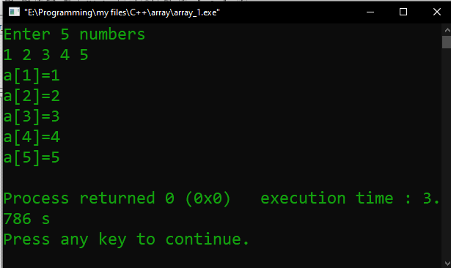

Problem No. 02
Name of the problem:
Write a program in C to read n number of values in an array and display it in reverse order
Introduction
Implementing program in C is very interesting. To implement the problem given above we should remember the procedure to display outcome. That is, we should consider about the required inputs, the particular process that will be applied upon the input data and the output whether it is desired or not. The given problem gives me an opportunity to have an exercise on the procedure.

Program:
//print reverse array numbers
#include<stdio.h>
int main()
{
int a[5],i;
printf("\tEnter 5 numbers\n");

for(i=1;i<=5;i++)
scanf("\t%d",&a[i]);

printf("\tOutput\n");

for(i=5;i>=1;i--)
printf("\ta[%d]=%d\n",i,a[i]);

return 0;

}
Output:
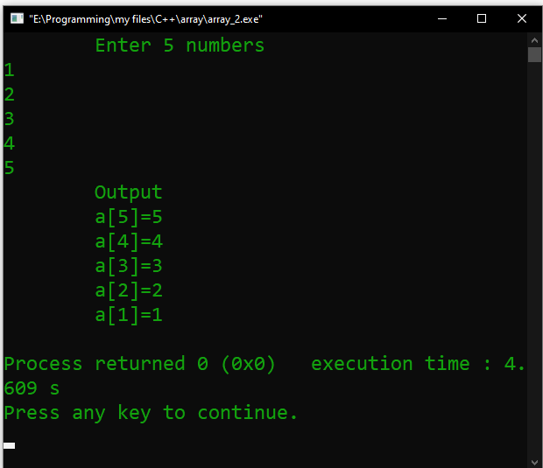

Problem No. 03
Name of the problem:
Write a program in C to find the sum of all elements of the array.
Introduction
Implementing program in C is very interesting. To implement the problem given above we should remember the procedure to display outcome. That is, we should consider about the required inputs, the particular process that will be applied upon the input data and the output whether it is desired or not. The given problem gives me an opportunity to have an exercise on the procedure.

Program:
//Summation of array numbers
#include<stdio.h>
int main()
{
int a[5],i,sum=0;
printf("Enter 5 numbers\n");

for(i=0;i<=4;i++)
scanf("%d",&a[i]);

for(i=0;i<5;i++)
sum=sum+a[i];

printf("The summation is: %d",sum);

return 0;

}
Output:
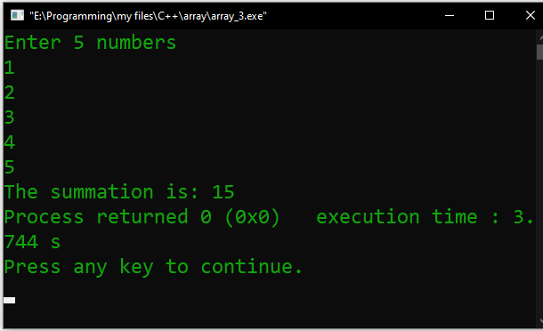

Problem No. 04
Name of the problem:
Write a program in C to find the maximum and minimum element in an array.
Introduction
Implementing program in C is very interesting. To implement the problem given above we should remember the procedure to display outcome. That is, we should consider about the required inputs, the particular process that will be applied upon the input data and the output whether it is desired or not. The given problem gives me an opportunity to have an exercise on the procedure.

Program:
//find Max & min value from array numbers
#include <stdio.h>
int main()
{
int i,m,s;
int a[5];
printf("Enter 5 numbers of elements:\n");
for (i=0; i<=4; ++i)
{
scanf("%d",&a[i]);
}
m=a[0];
s=a[0];
for (i=1; i<=4; ++i)
{
if (a[0]<a[i])
{m=a[i];}
if (a[0]>a[i])
{s=a[i];}
}
printf("Maximum element = %d\n",m);
printf("Minimum element = %d",s);
return 0;
}
Output:
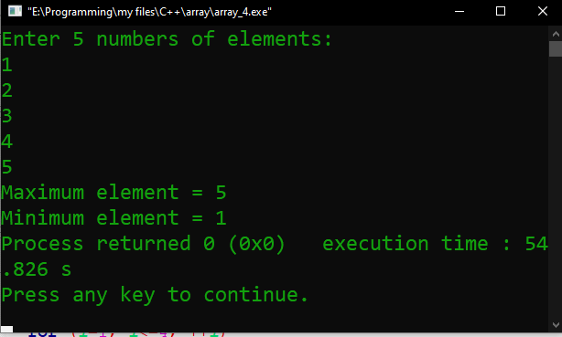

Problem No. 05
Name of the problem:
Write a program in C to sort elements of array in ascending order
Introduction
Implementing program in C is very interesting. To implement the problem given above we should remember the procedure to display outcome. That is, we should consider about the required inputs, the particular process that will be applied upon the input data and the output whether it is desired or not. The given problem gives me an opportunity to have an exercise on the procedure.

Program:
//sort elements of array in ascending order
#include <stdio.h>
int main()
{
int i,arr[5],j;
int temp=0;
printf("Enter any 5 numbers:\n");
for(i=1;i<=5;i++)
scanf("%d",&arr[i]);
for(i=1;i<=5;i++)
printf("arr[%d]=%d\n",i,arr[i]);
//Sort the array in ascending order
for (i=1; i<=5; i++)
{
for (j=i+1; j<=5; j++)
{
if(arr[i] > arr[j])
{
temp = arr[i];
arr[i] = arr[j];
arr[j] = temp;
}
}
}
printf("\n");
//Displaying elements of array after sorting
printf("Elements of array sorted in ascending order: \n");
for (i=1; i<=5; i++)
{
printf("%d ", arr[i]);
}
return 0;
}
Output:
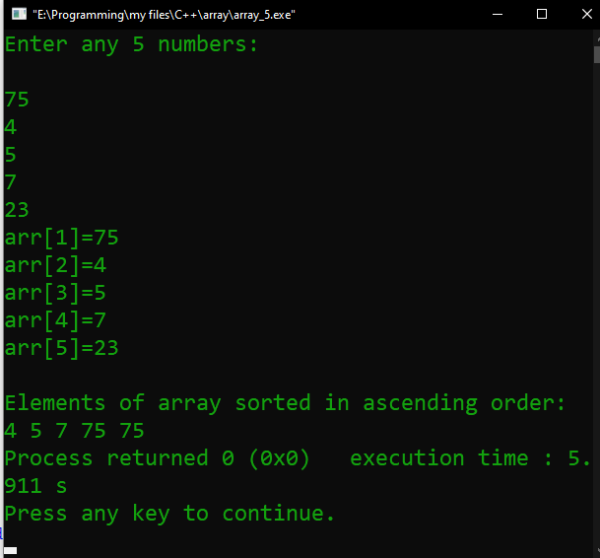

Problem No. 06
Name of the problem:
Write a program in C program to Insert an Element in an Array.
Introduction
Implementing program in C is very interesting. To implement the problem given above we should remember the procedure to display outcome. That is, we should consider about the required inputs, the particular process that will be applied upon the input data and the output whether it is desired or not. The given problem gives me an opportunity to have an exercise on the procedure.

Program:
//Insert an Element in an Array
#include<stdio.h>
int main()
{
char a[0],i;
printf("Enter an element\n");
scanf("%c",&a[0]);
printf("Entered element is %c",a[0]);
return 0;

}

Output:
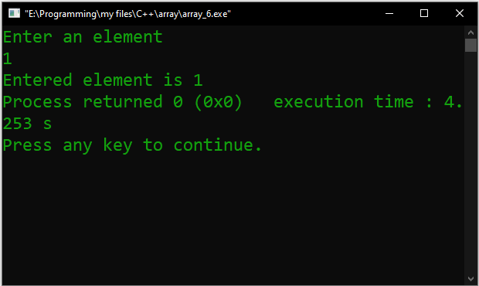

Problem No. 07
Name of the problem:
Write a program in C to print all unique elements in an array
Introduction
Implementing program in C is very interesting. To implement the problem given above we should remember the procedure to display outcome. That is, we should consider about the required inputs, the particular process that will be applied upon the input data and the output whether it is desired or not. The given problem gives me an opportunity to have an exercise on the procedure.

Program:
//Print all unique elements of an array
#include <stdio.h>
int main()
{
int a[100],n,ctr=0;
int i,j,k;
printf("\tPrint all unique elements of an array\n");
printf("Input the number of elements to be stored in the array: ");
scanf("%d",&n);
printf("Input %d elements in the array :\n",n);
for(i=0;i<n;i++)
{
printf("element - %d : ",i);
scanf("%d",&a[i]);
}
printf("\nThe unique elements found in the array are:\n");
for(i=0; i<n; i++)
{
ctr=0;
for(j=0,k=n; j<k+1; j++)
{
/*Increment the counter when the search value is duplicate.*/
if (i!=j)
{
if(a[i]==a[j])
{
ctr++;
}
}
}
if(ctr==0)
{
printf("%d ",a[i]);
}
}
printf("\n\n");
return 0;
}
Output:
